ASSIGNMENT 4

Name: - Khelan Vaishnav

ID NO.: - 21EL038

Division: - 04

Year: - 2023-24

Subject: - Digital System Design (3EL42)

Branch: - Electronics (EL)

Q1. BCD TIMECOUNT

VERILOG CODE:-

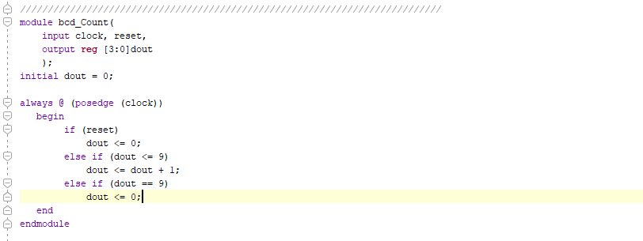

TEST BENCH:-

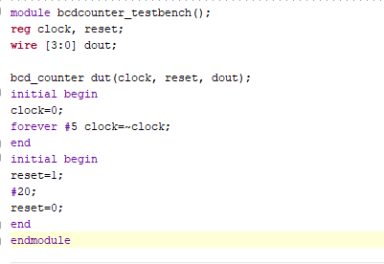

RTL SCHEMATIC:-

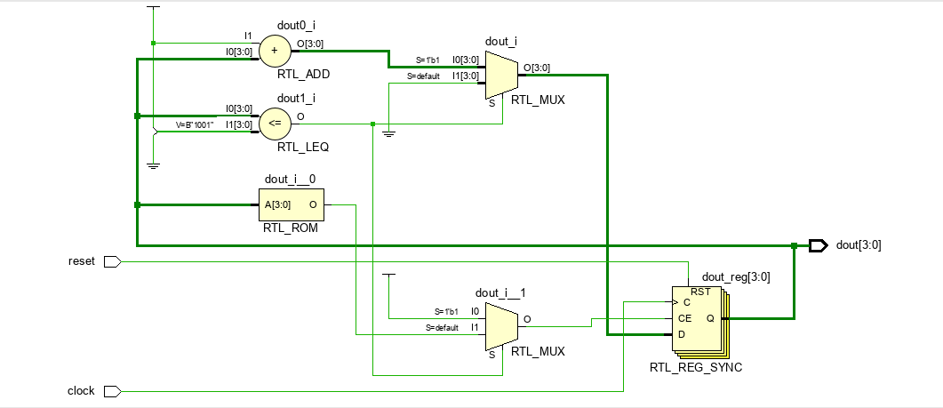

SYNTHESIS REPORT:-

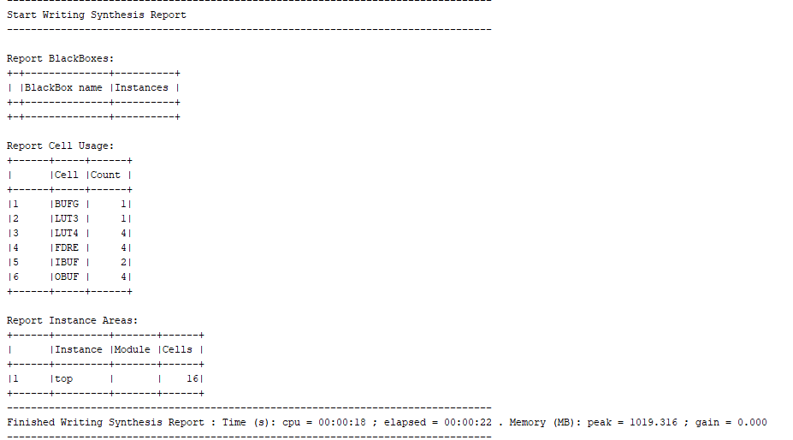

POWER REPORT:-

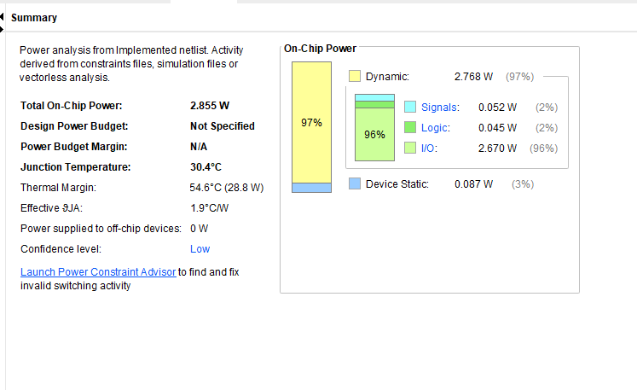

Q2. 3-1 MUX

VERILOG CODE:-

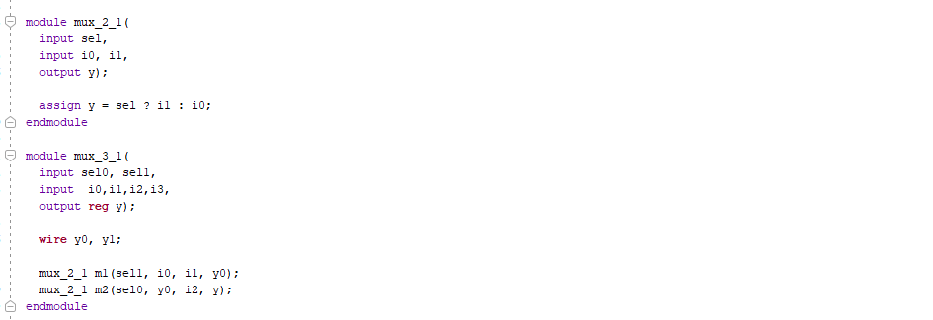

TESTBENCH:-

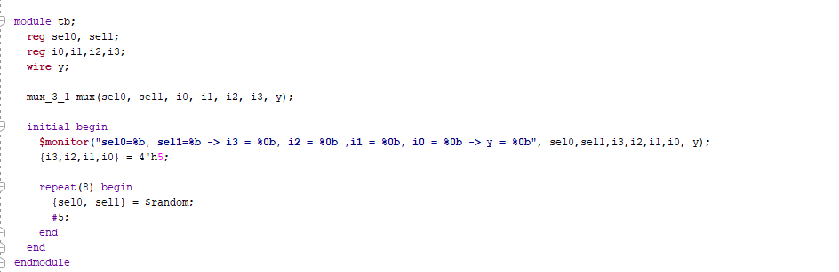

RTL SCHEMATIC:-

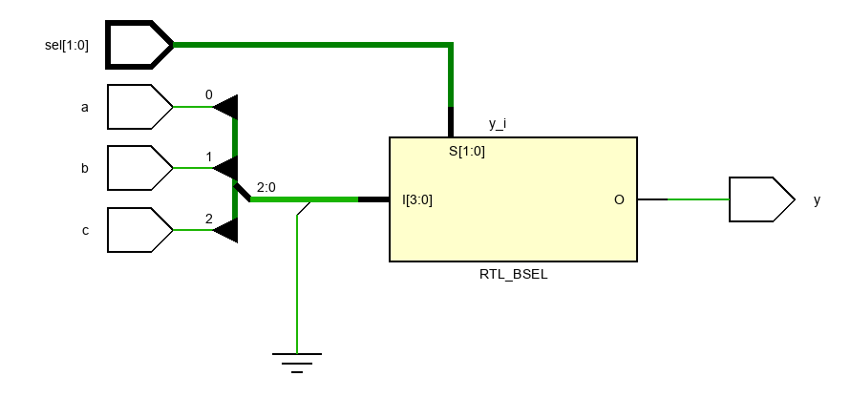

SYNTHESIS REPORT:-

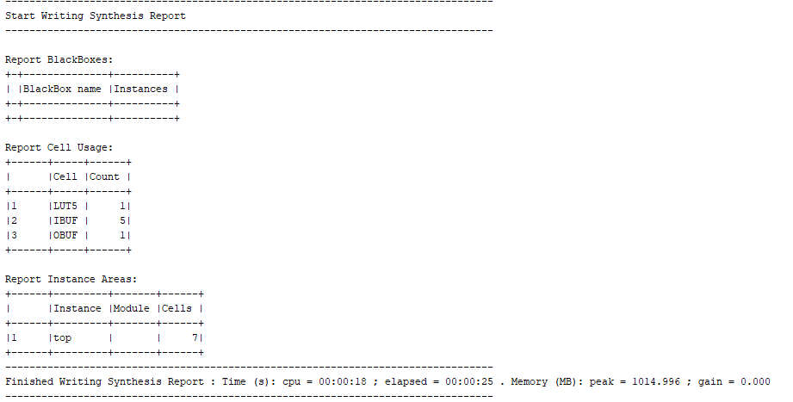

POWER REPORT:-

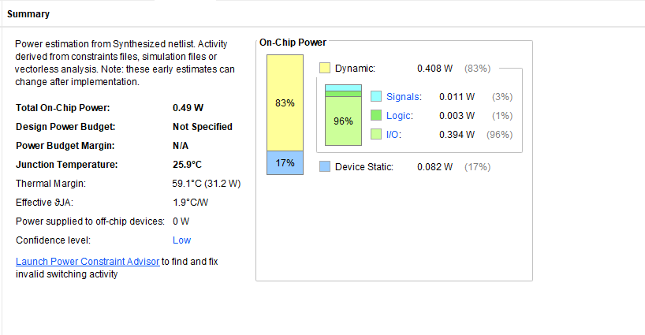

Q3. BCD TO SEVEN SEGMENT DISPLAY

VERILOG CODE:-

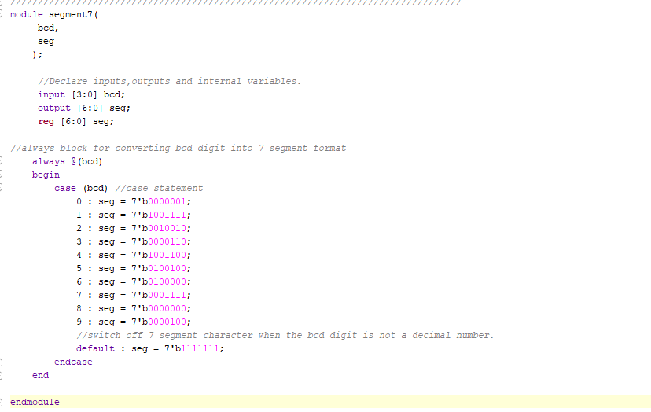

TESTBENCH:-

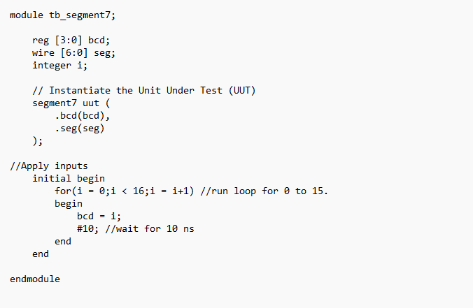

RTL SCHEMATIC:-

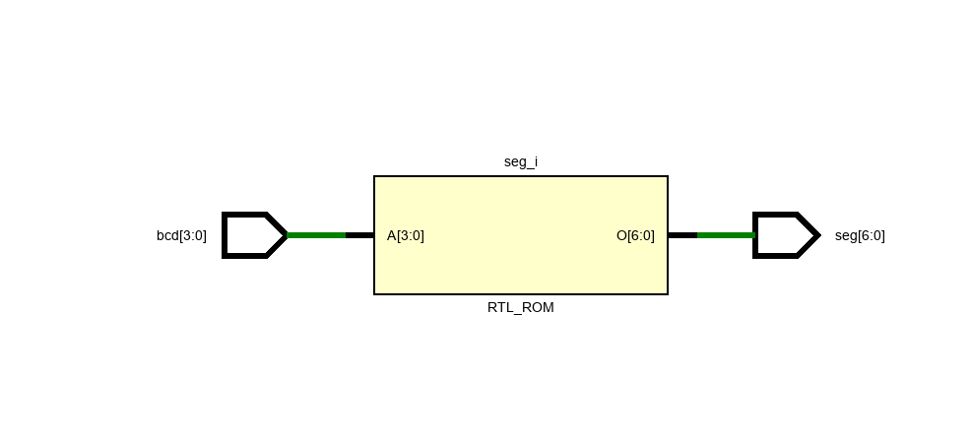

SYNTHESIS REPORT:-

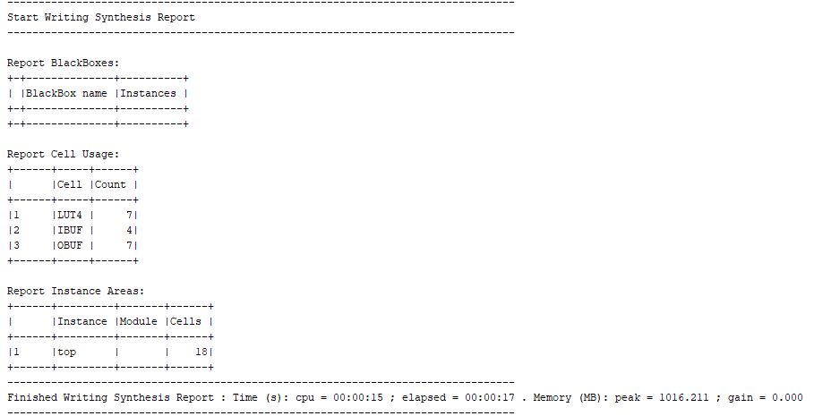

POWER REPORT:-

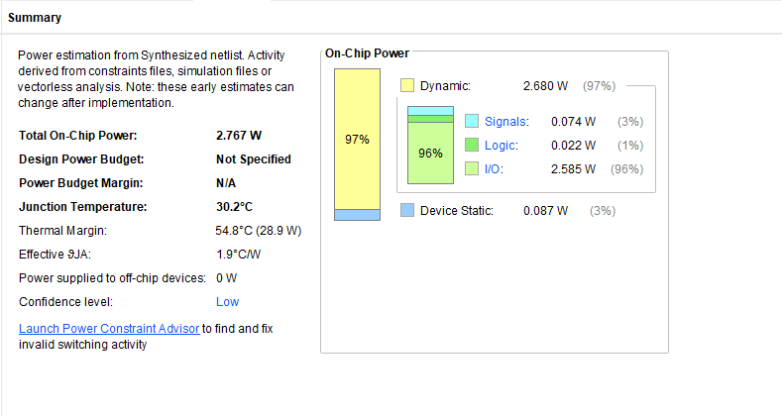

Q4. D LATCH USING 2:1 MUX

VERILOG CODE:-

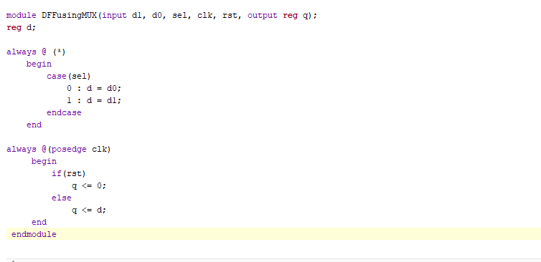

TESTBENCH:-

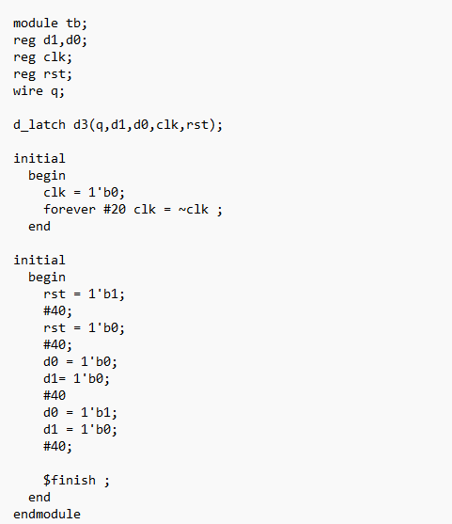

RTL SCHEMATIC:-

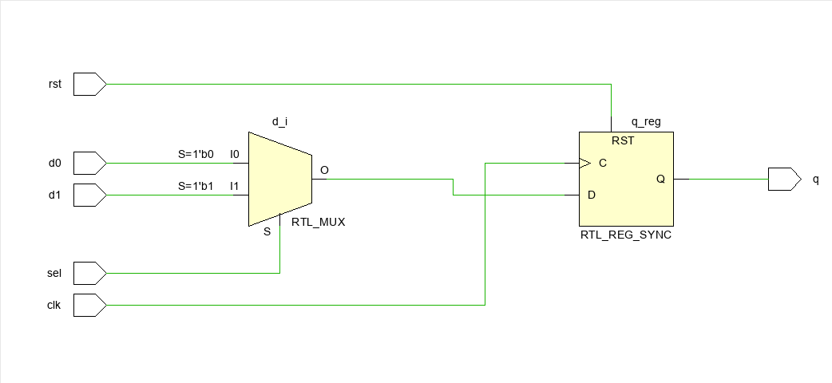

SYNTHESIS REPORT:-

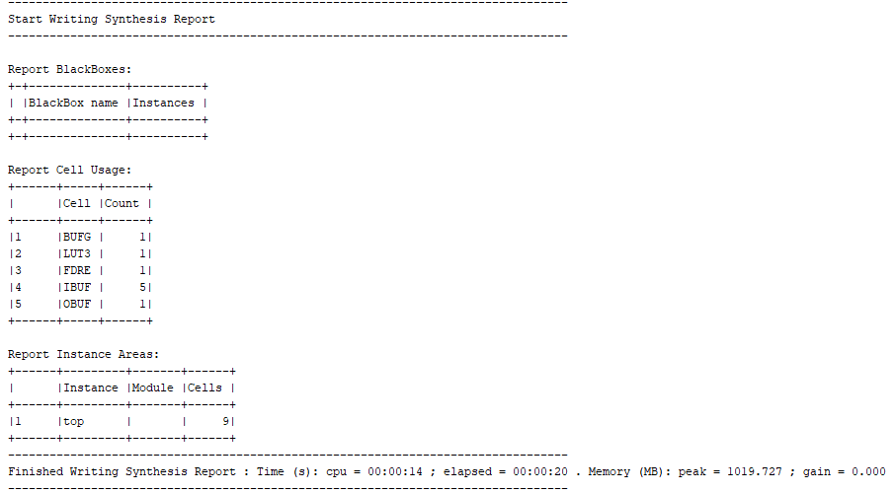

POWER REPORT:-

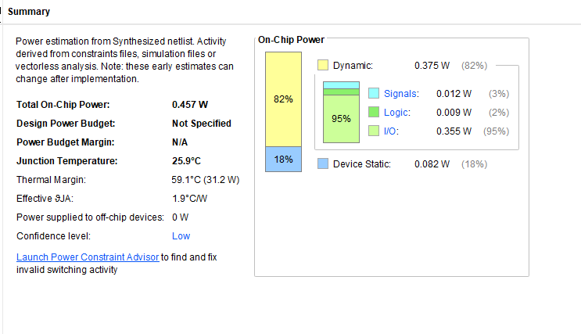

Q5. 8-BIT BARREL SHIFTER

VERILOG CODE:-

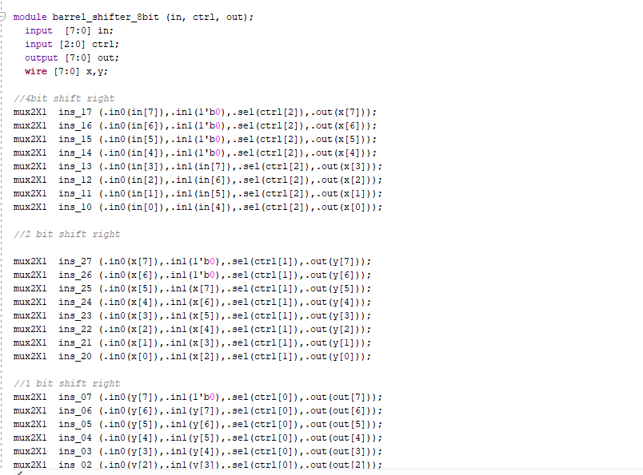

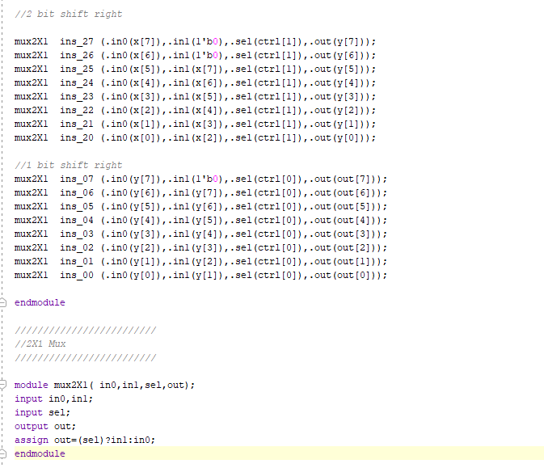

TESTBENCH:-

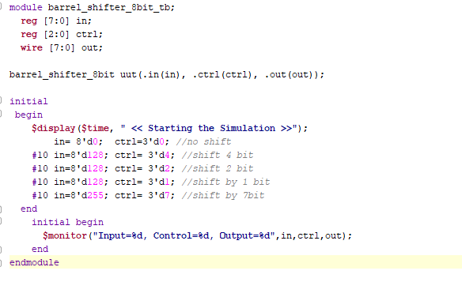

RTL SCHEMATIC:-

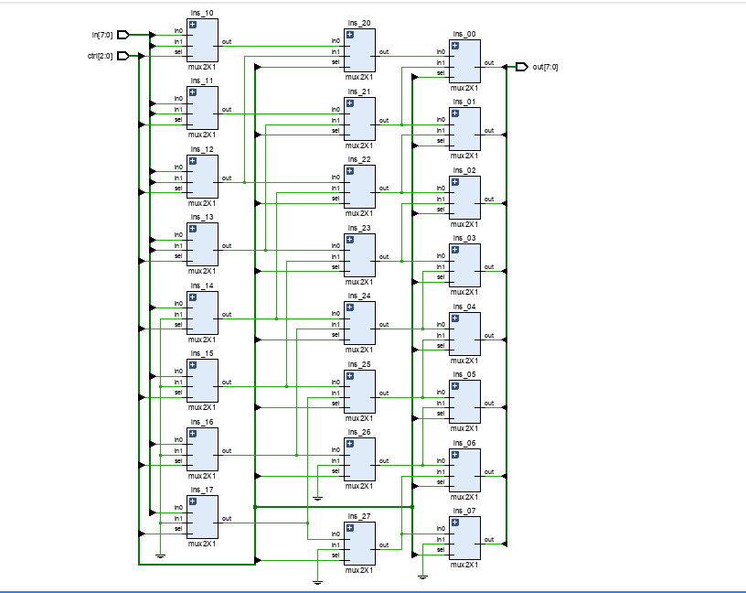

SYNTHESIS REPORT:-

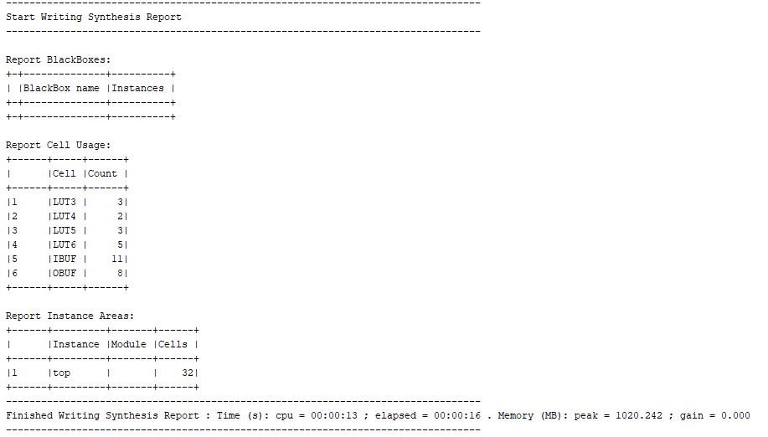

POWER REPORT:-

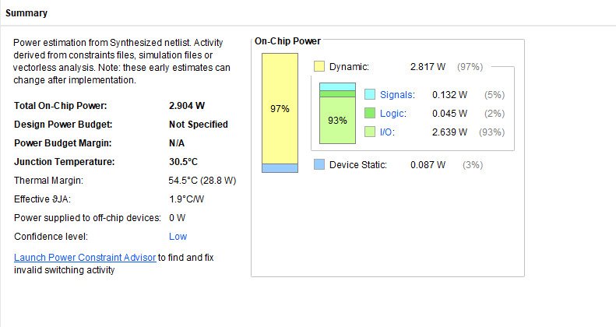

Q6. 1-BIT COMPARATOR USING 4X1 MUX

VERILOG CODE:-

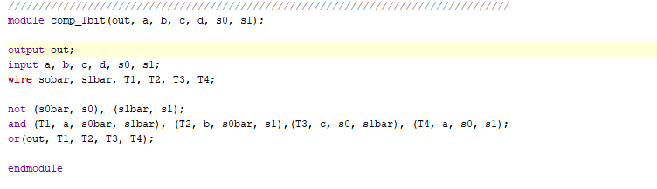

TESTBENCH:-

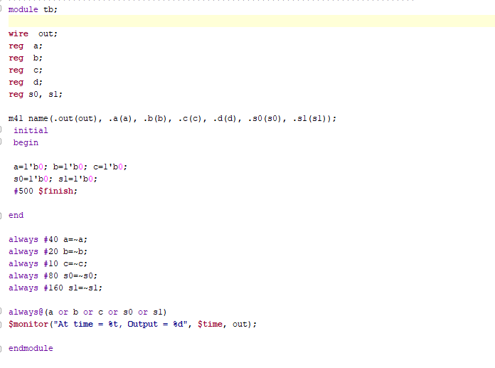

RTL SCHEMATIC:-

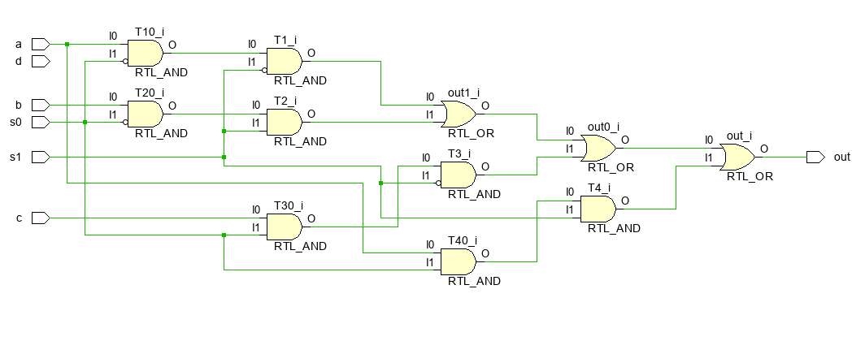

SYNTHESIS REPORT:-

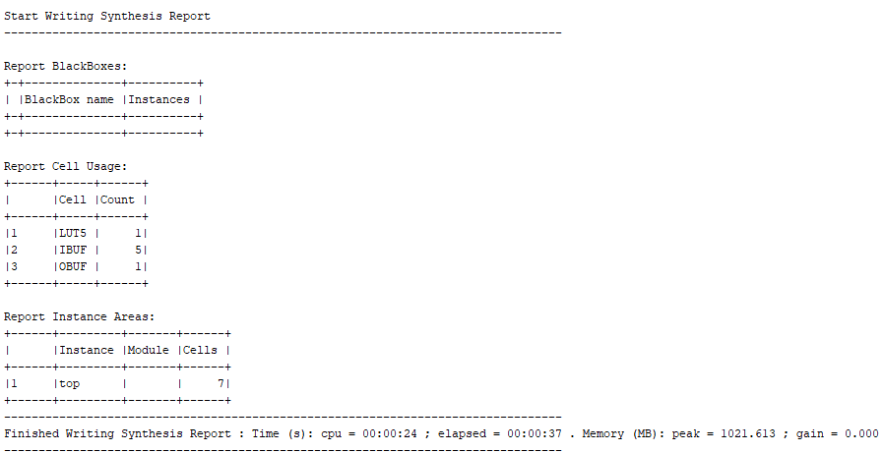

POWER REPORT:-

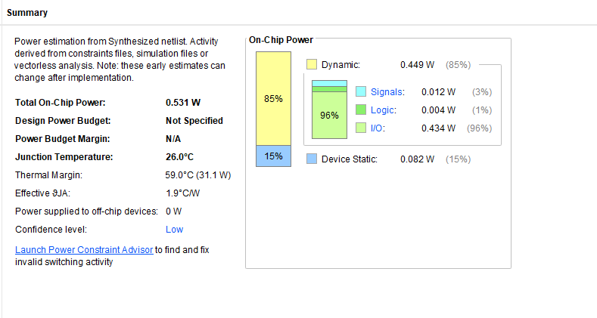

Q7.LOGICAL, ALGEBRAIC, AND ROTATE SHIFT OPERATIONS

VERILOG CODE:-

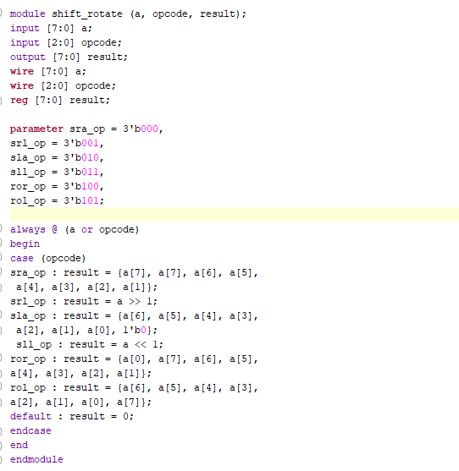

TESTBENCH:-

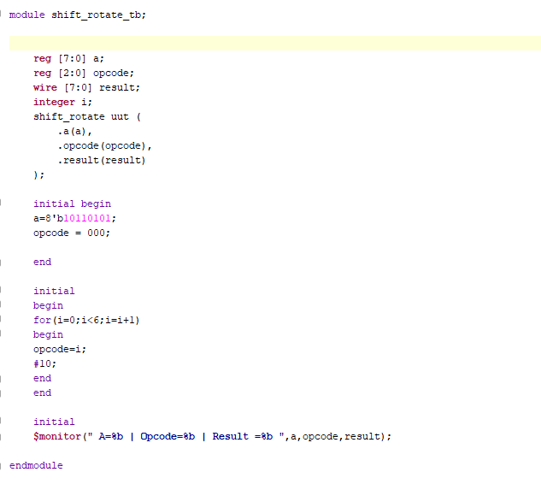

RTL SCHEMATIC:-

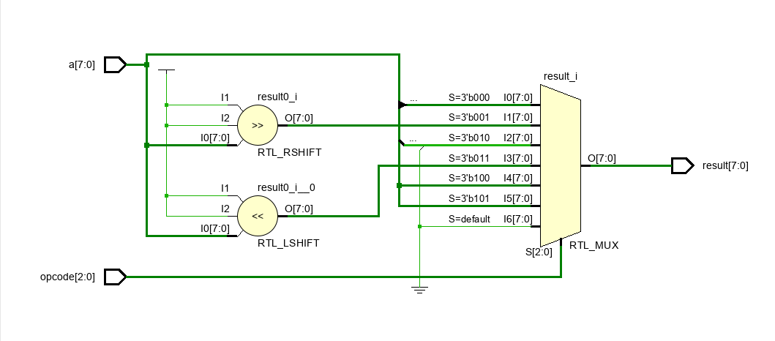

SYNTHESIS REPORT:-

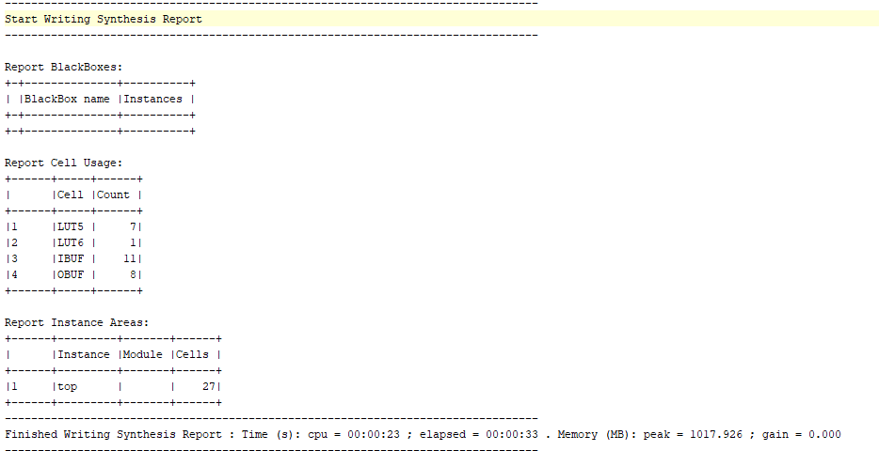

POWER REPORT:-

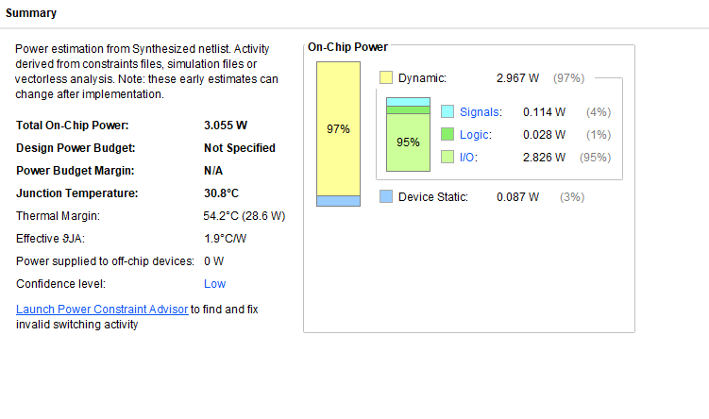

Q8. ALU

VERILOG CODE:-

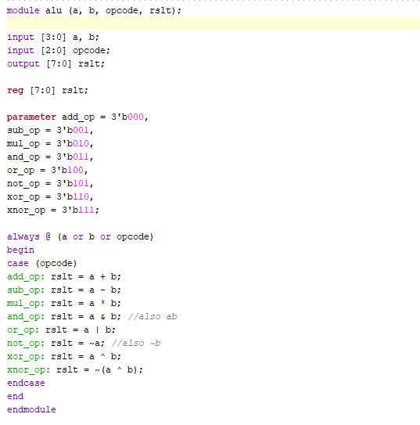

TEST BENCH:-

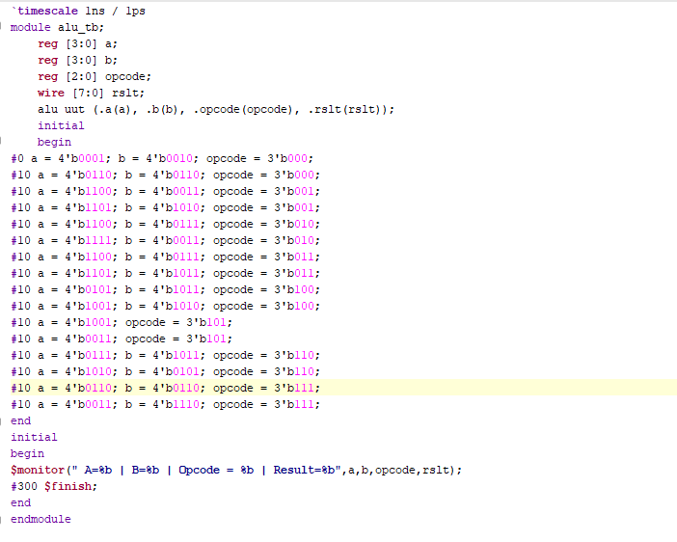

RTL SCHEMATIC:-

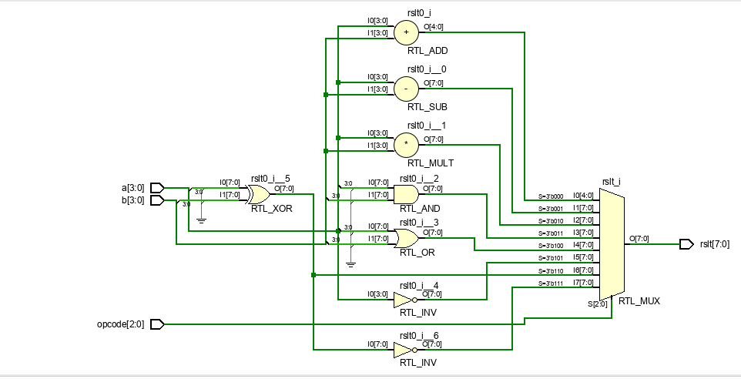

SYNTHESIS REPORT:-

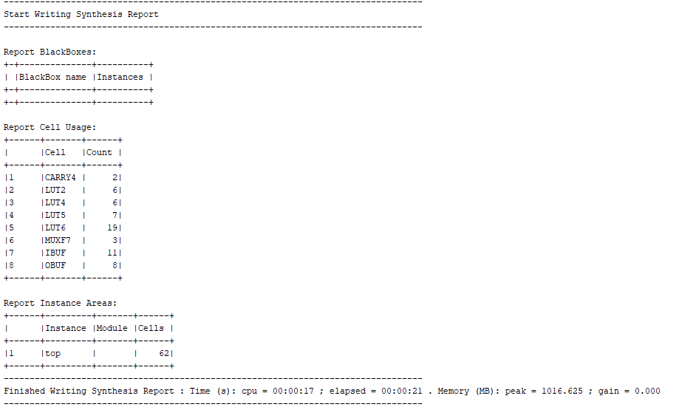

POWER REPORT:-

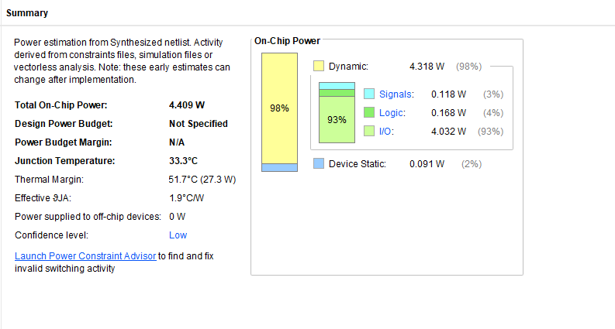

Q9. 4-BIT ASYNCHRONOUS DOWN COUNTER

VERILOG CODE:-

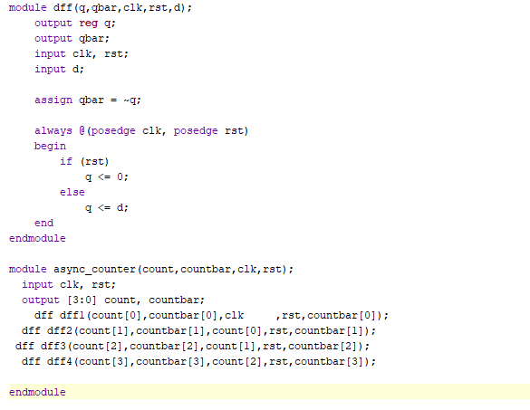

TESTBENCH:-

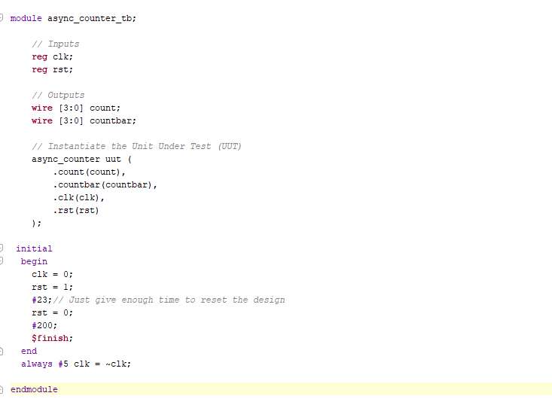

RTL SCHEMATIC:-

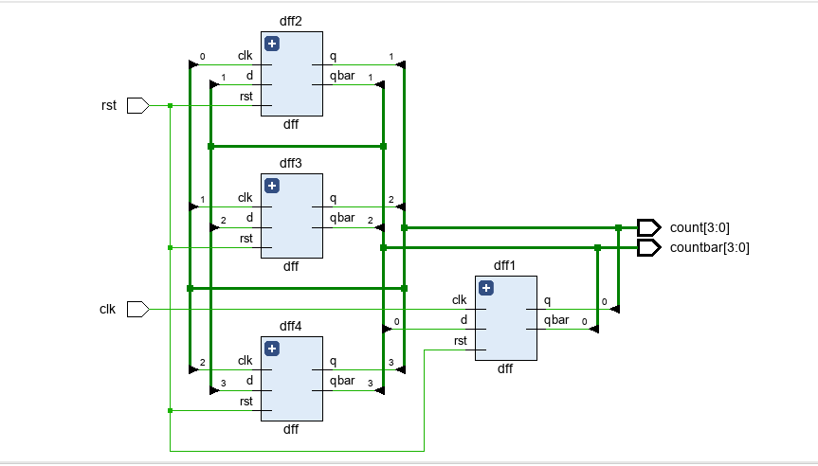

SYNTHESIS REPORT:-

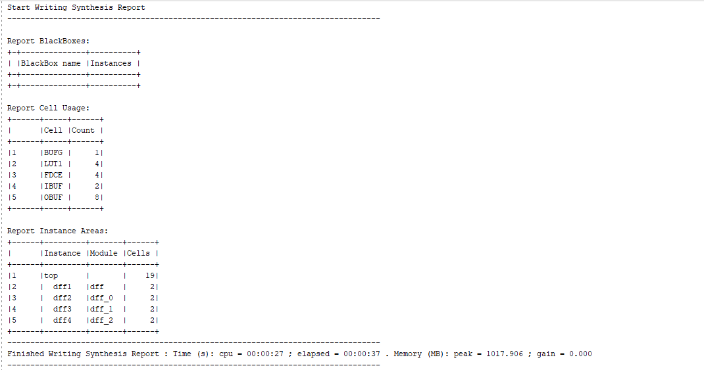

POWER REPORT:-

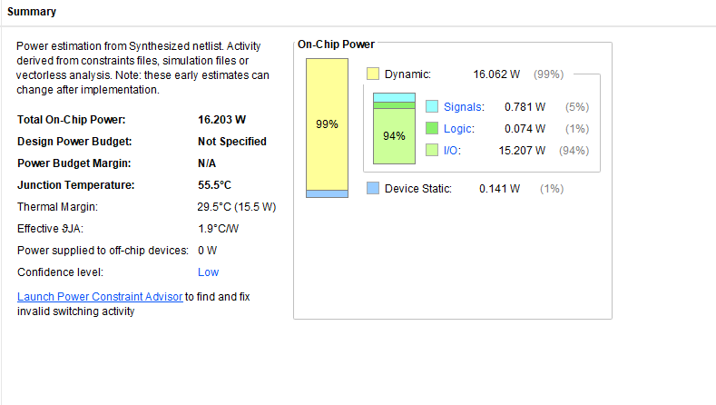

Q10. MOD-N UPDOWN COUNTER

VERILOG CODE:-

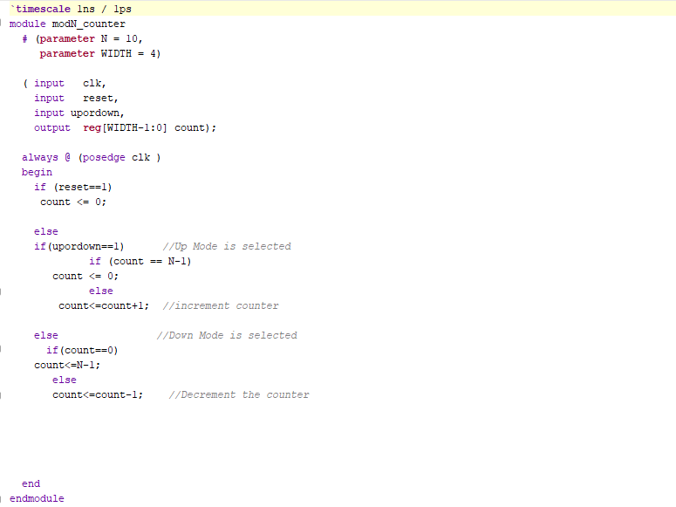

TESTBENCH:-

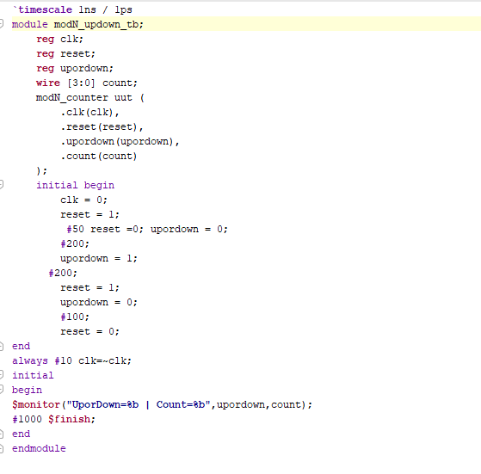

RTL SCHEMATIC:-

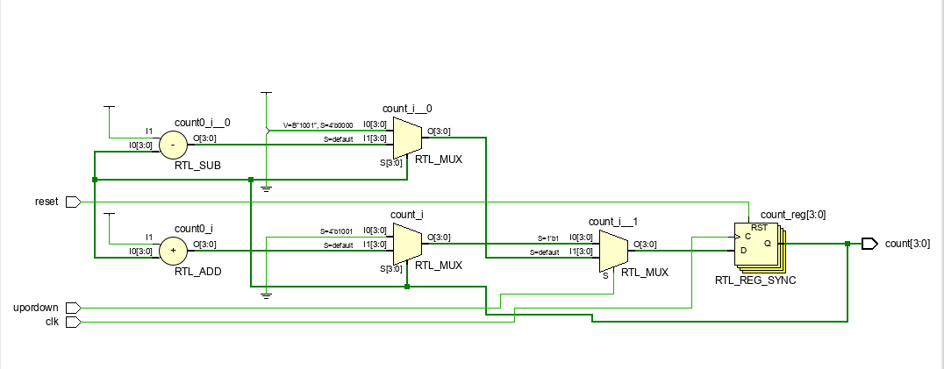

SYNTHESIS REPORT:-

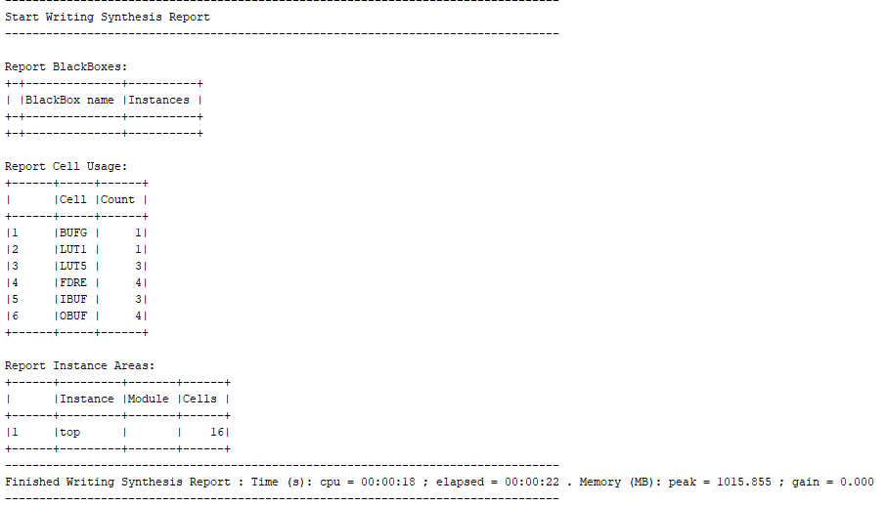

POWER REPORT:-

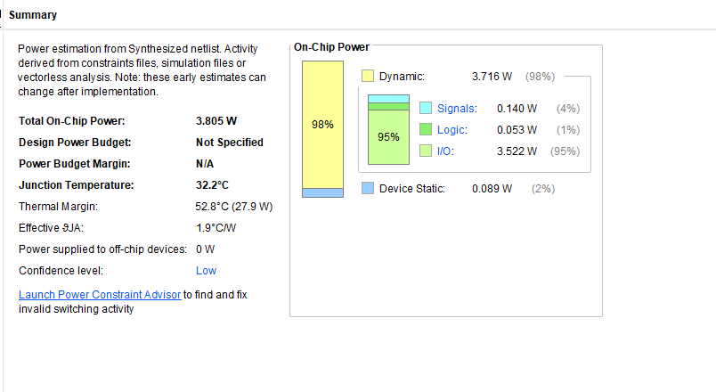

Q11. UNIVERSAL BINARY COUNTER

VERILOG CODE:-

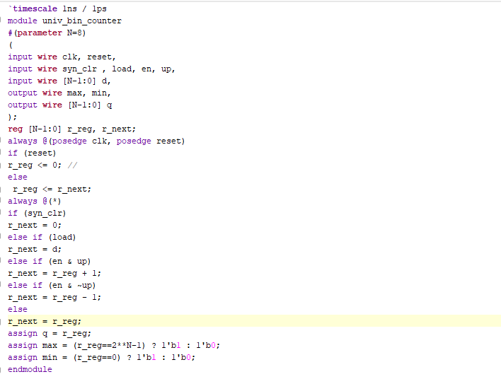

TESTBENCH:-

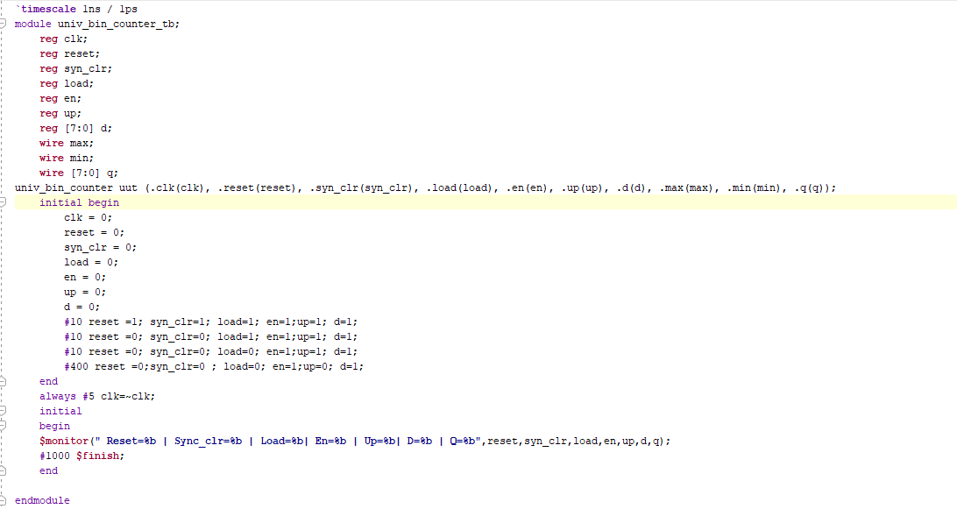

RTL SCHEMATIC:-

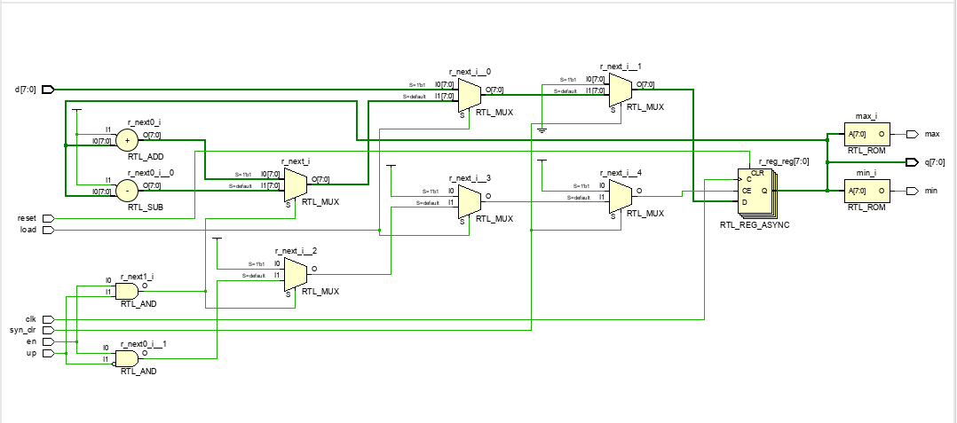

SYNTHESIS REPORT:-

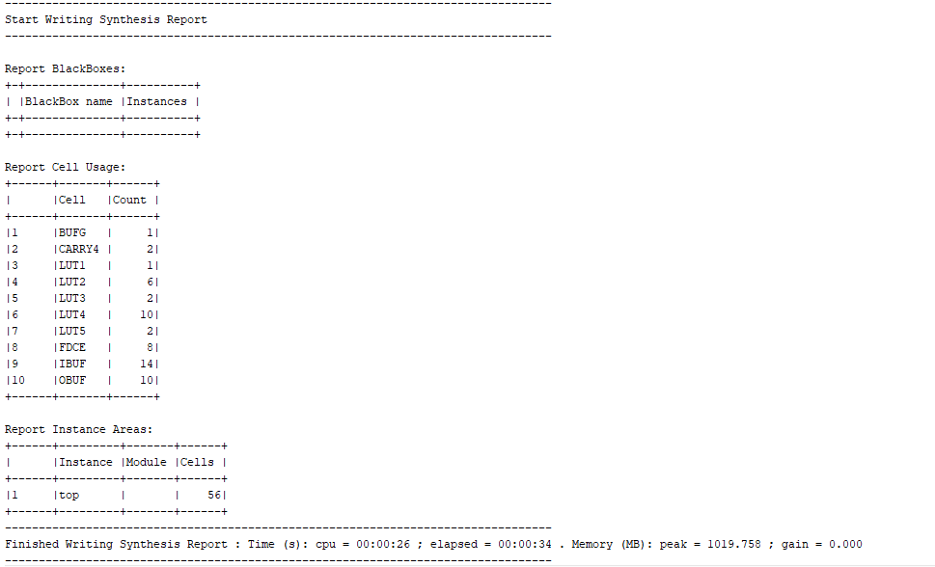

POWER REPORT:-

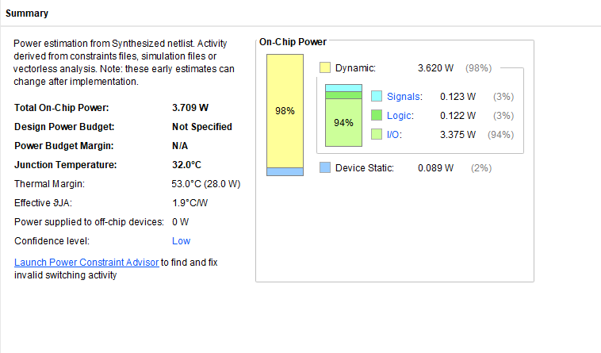

Q12. UNIVERSAL SHIFT REGISTER

VERILOG CODE:-

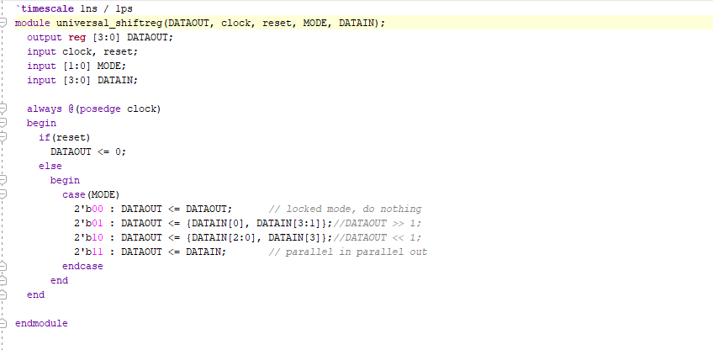

TESTBENCH:-

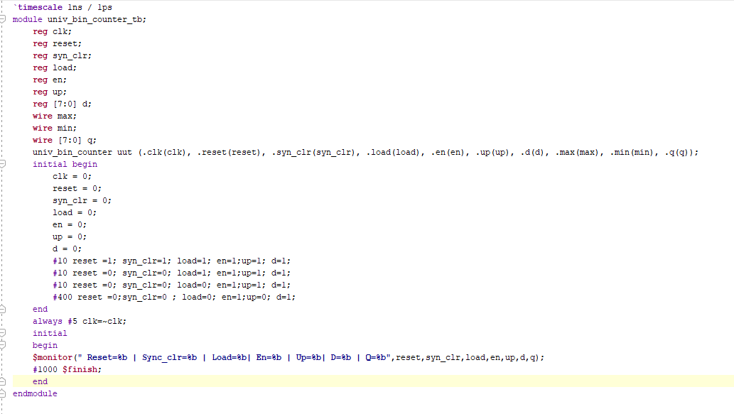

RTL SCHEMATIC:-

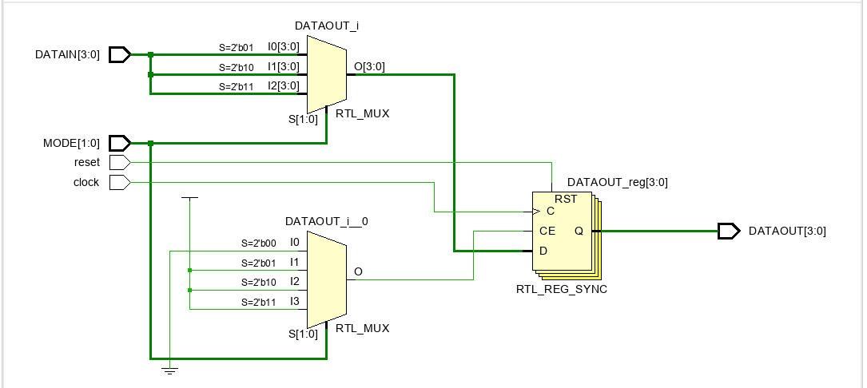

SYNTHESIS REPORT:-

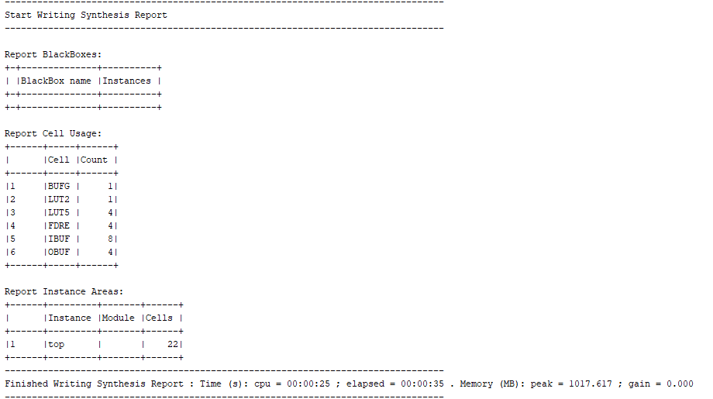

POWER REPORT:-

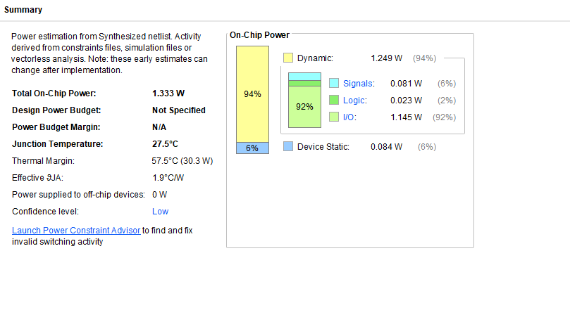

Q13. CN( CHANGE-NO CHANGE FLIPFLOP) USING 2:1 MUX

VERILOG CODE:-

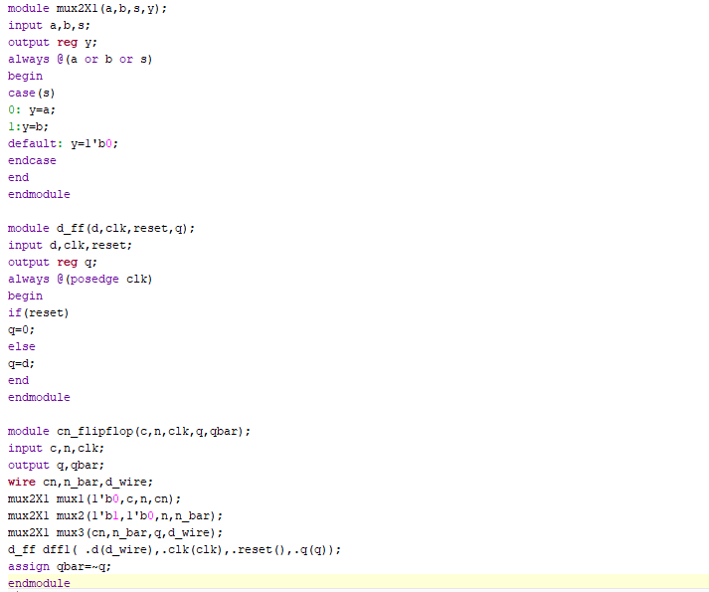

TESTBENCH:-

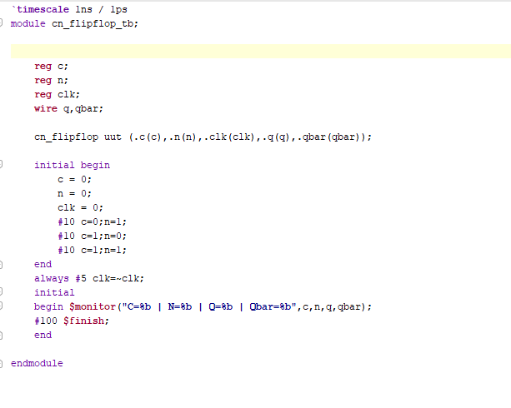

RTL SCHEMATIC:-

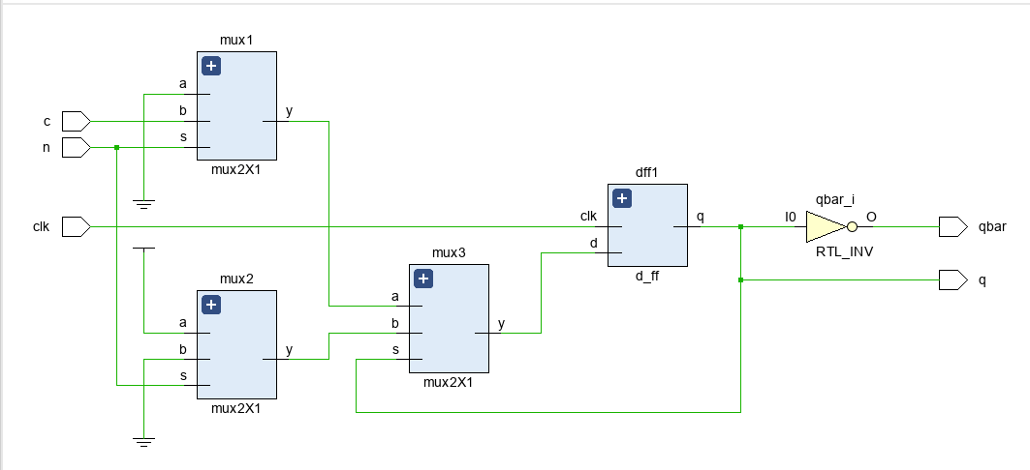

SYNTHESIS REPORT:-

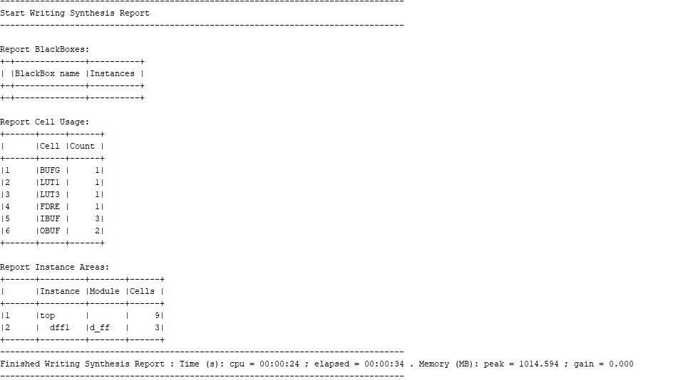

POWER REPORT:-

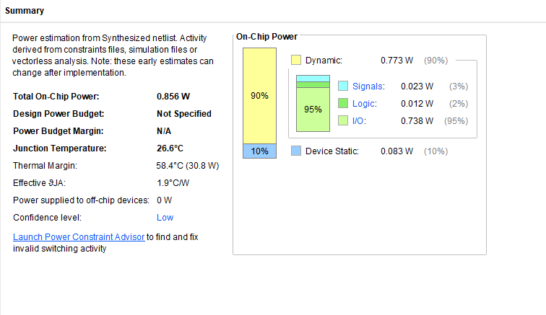

Q14.FREQUENCY DIVIDER BY ODD NUMBERS

VERILOG CODE:-

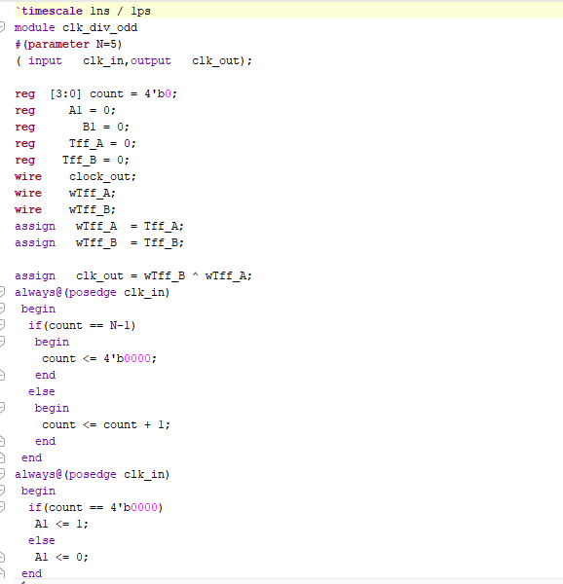

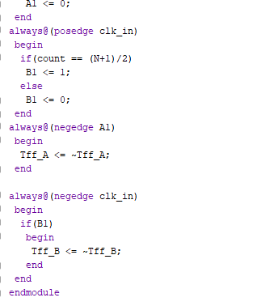

TESTBENCH:-

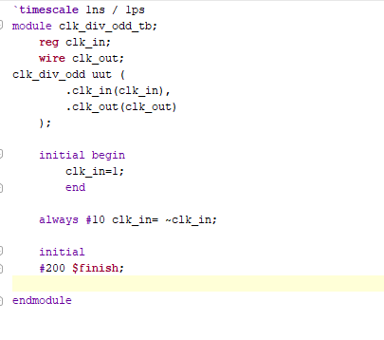

RTL SCHEMATIC:-

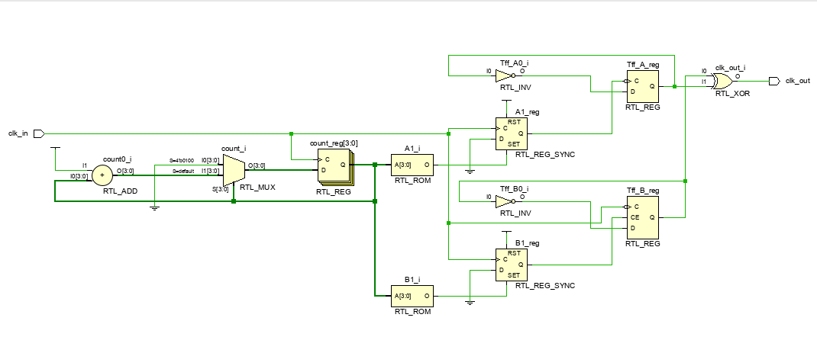

SYNTHESIS REPORT:-

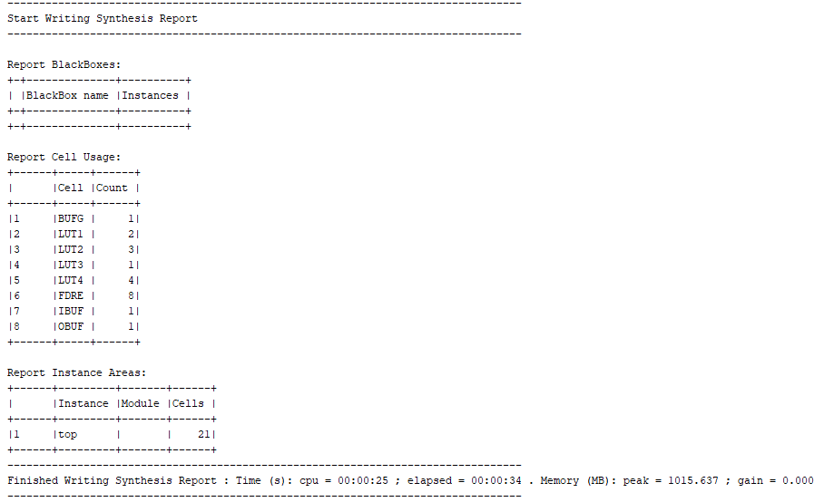

POWER REPORT:-

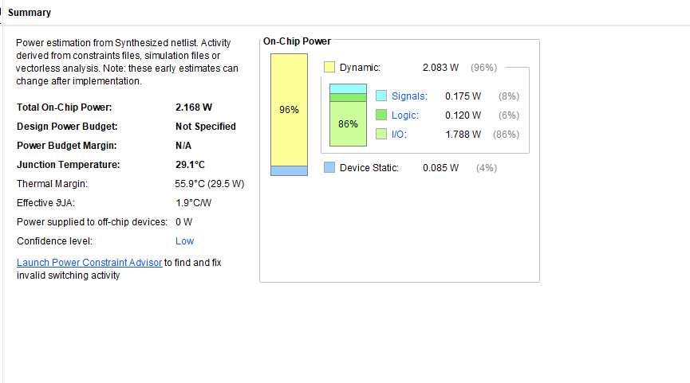

Q15. GREATEST COMMON DIVISOR USING BEHAVIOURAL MODELLING

VERILOG CODE:-

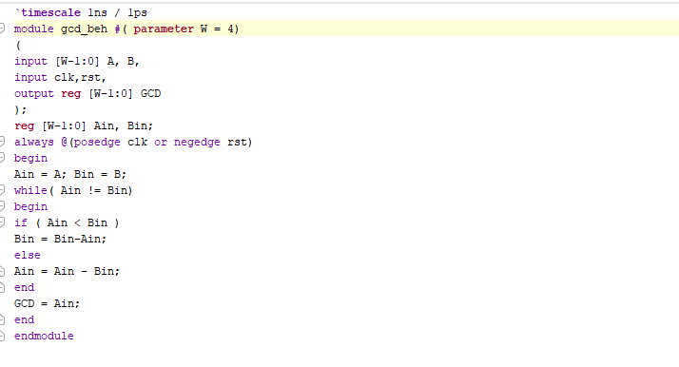

TESTBENCH:-

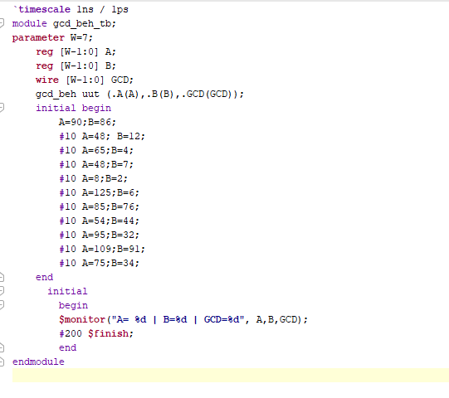

Q16.SINGLE PORT RAM

VERILOG CODE:-

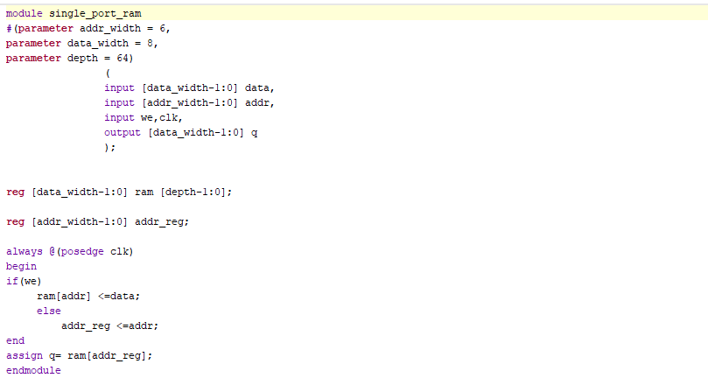

TESTBENCH:-

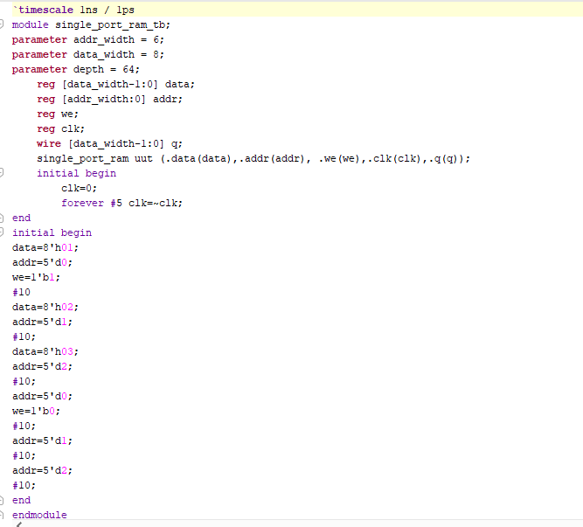

RTL SCHEMATIC:-

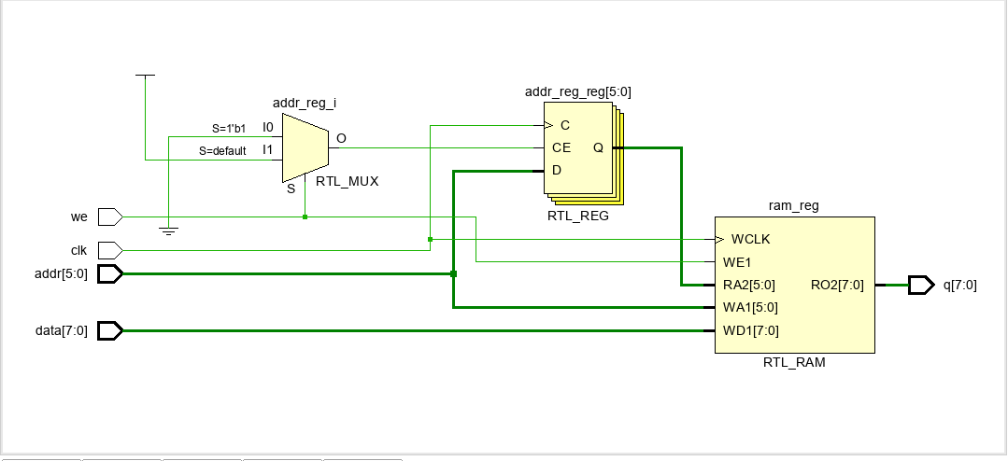

SYNTHESIS REPORT:-

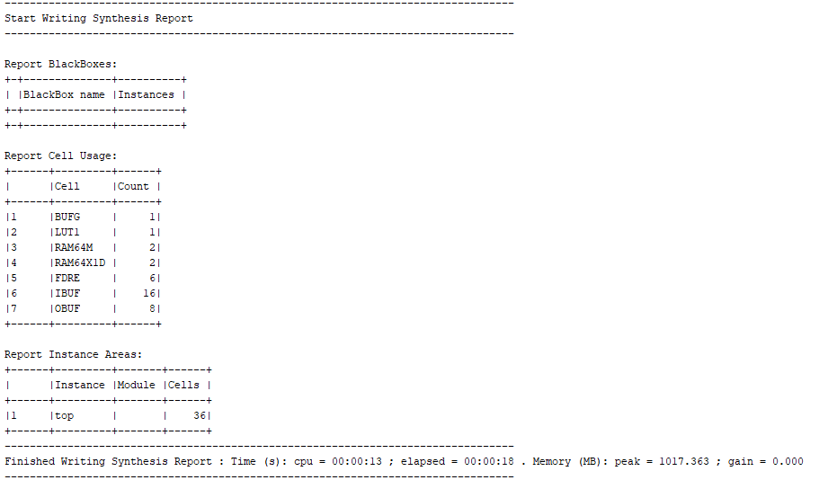

POWER REPORT:-

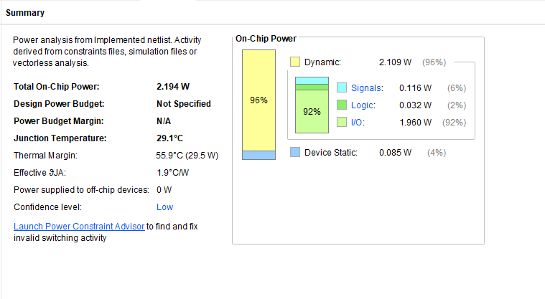

Q17. DUAL PORT RAM

VERILOG CODE:-

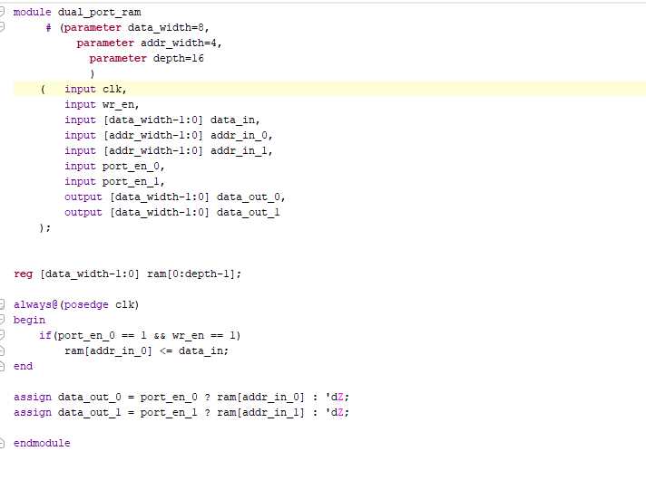

TESTBENCH:-

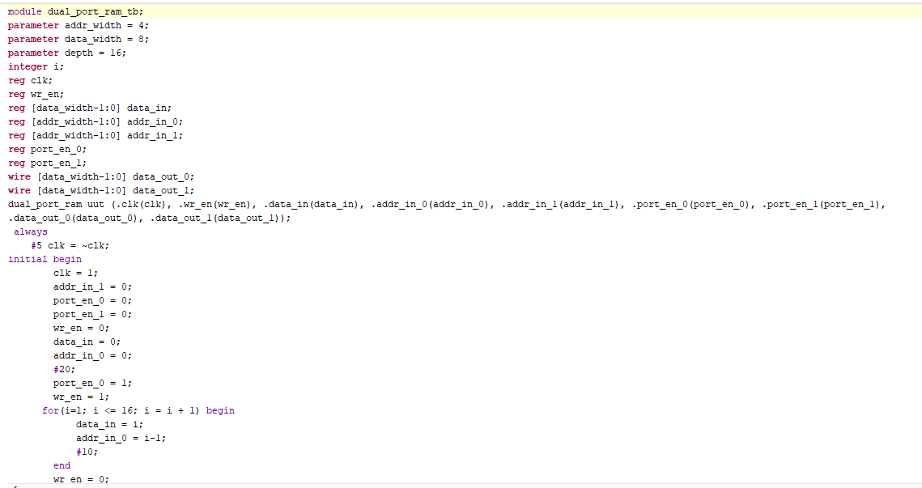

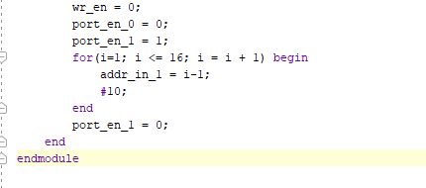

RTL SCHEMATIC:-

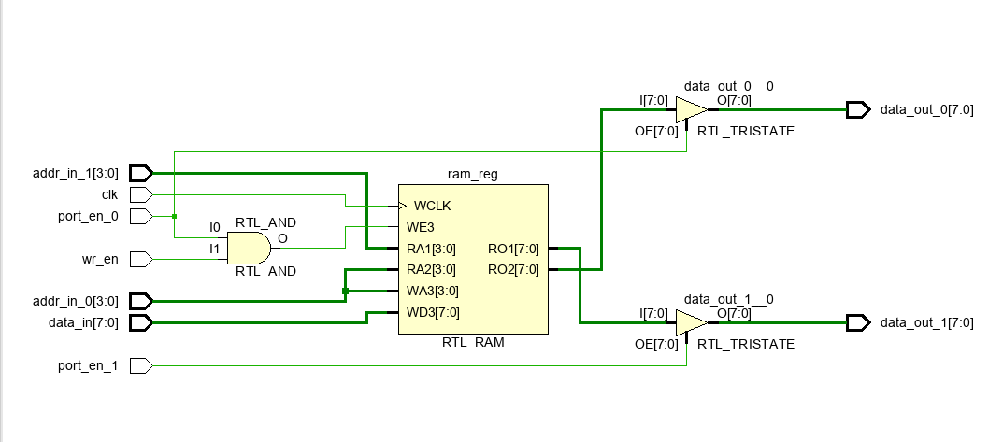

SYNTHESIS REPORT:-

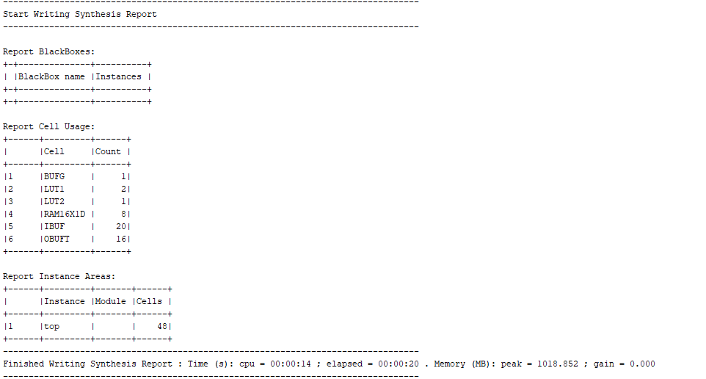

POWER REPORT:-

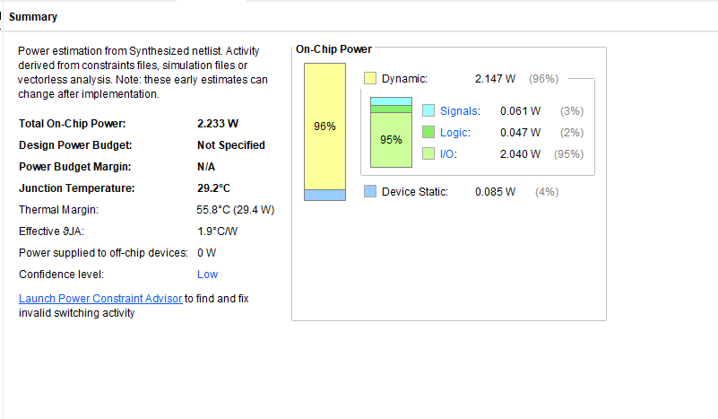

Q18. CLOCK BUFFER

VERILOG CODE:-

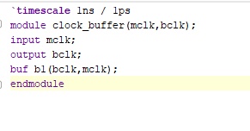

TESTBENCH:-

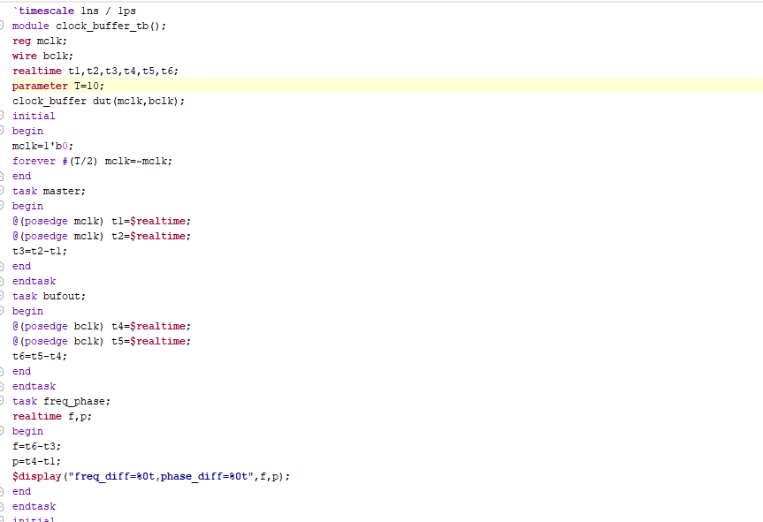

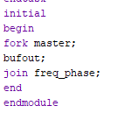

RTL SCHEMATIC:-

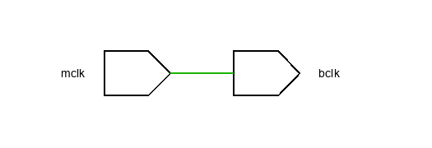

SYNTHESIS REPORT:-

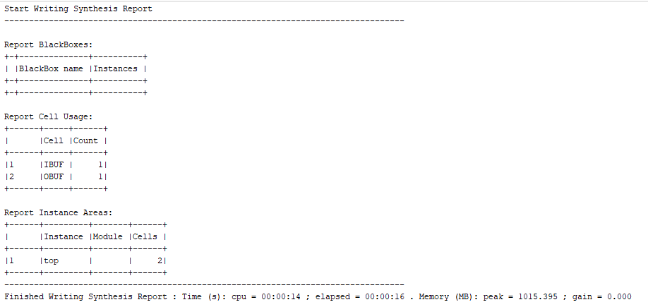

POWER REPORT:-

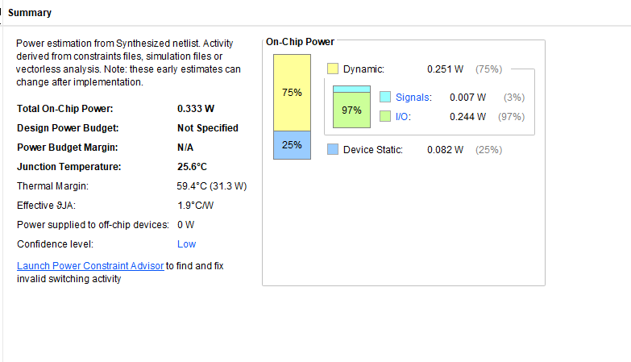

Q19. SYNCHRONOUS FIFO

VERILOG CODE:-

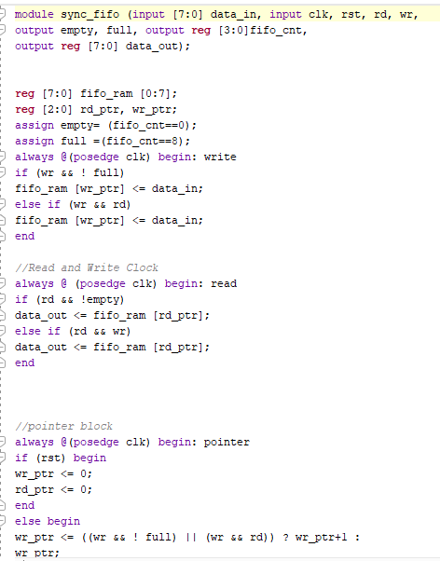

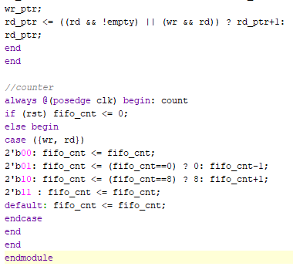

TESTBENCH:-

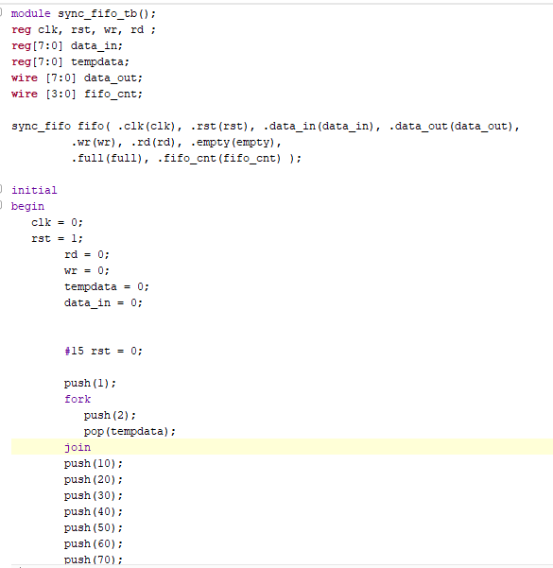

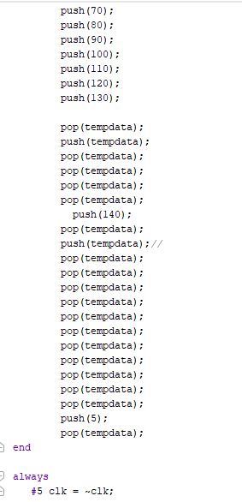

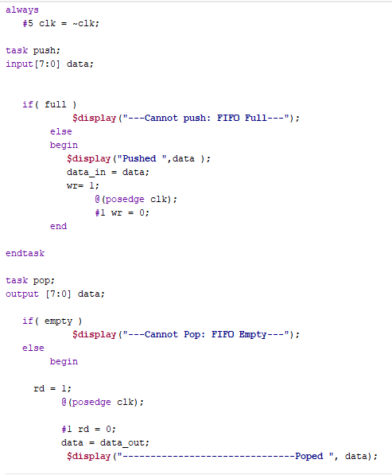

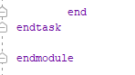

RTL SCHEMATIC:-

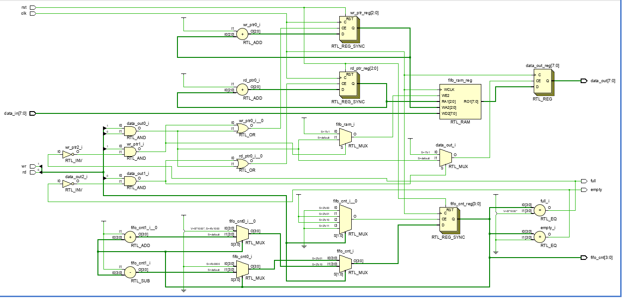

SYNTHESIS REPORT:-

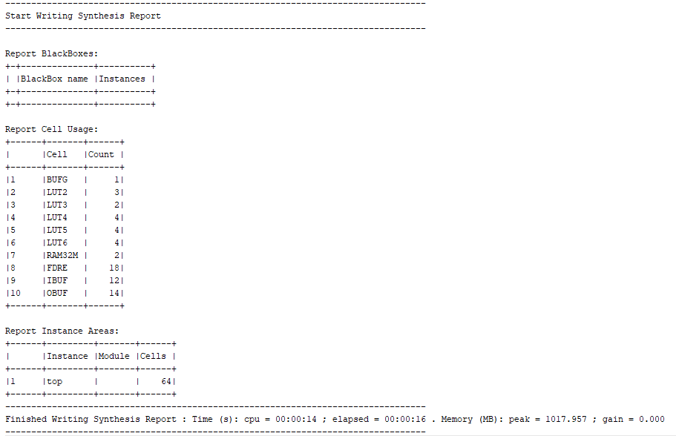

POWER REPORT:-

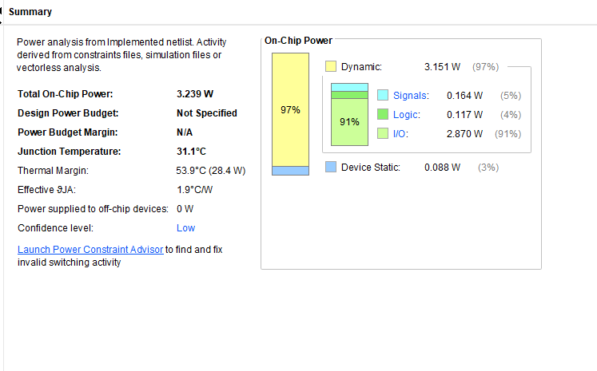

Q20. PRIORITY ENCODER

VERILOG CODE:-

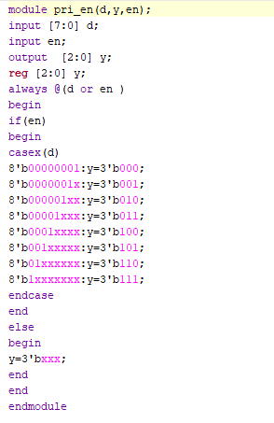

TEST BENCH:-

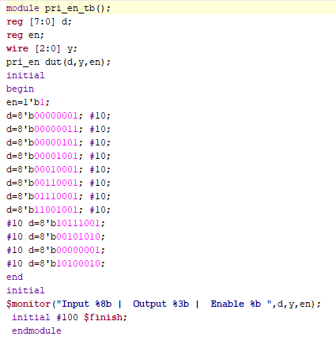

RTL SCHEMATIC:-

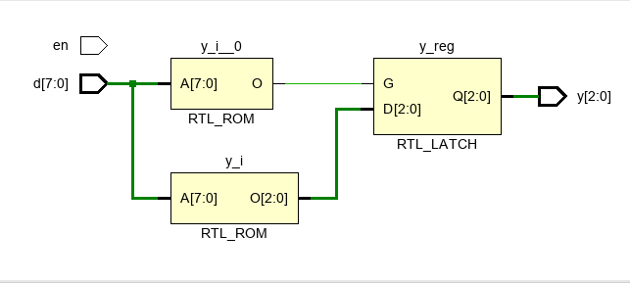

SYNTHESIS REPORT:-

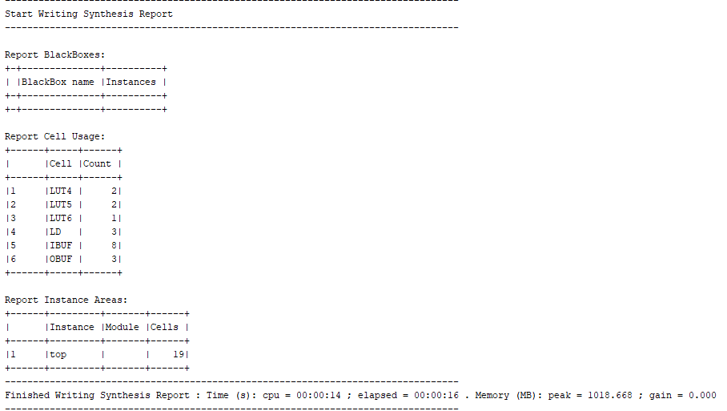

POWER REPORT:-

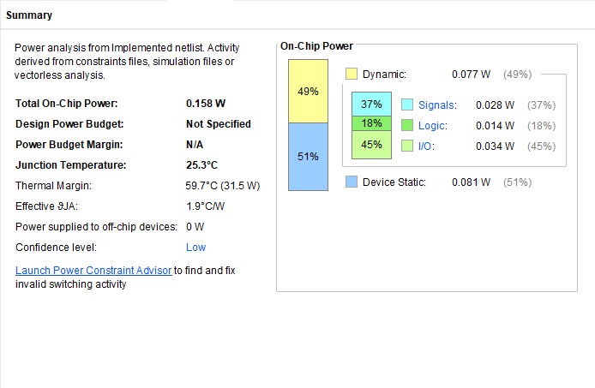

Q21. SEVEN SEGMENT DISPLAY USING ROM

VERILOG CODE:-

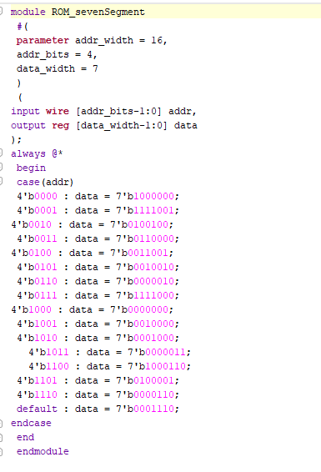

TESTBENCH:-

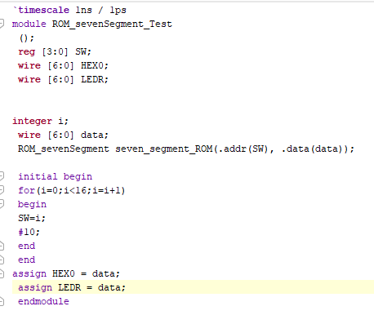

RTL SCHEMATIC:-

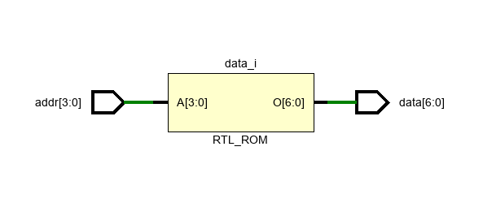

SYNTHESIS REPORT:-

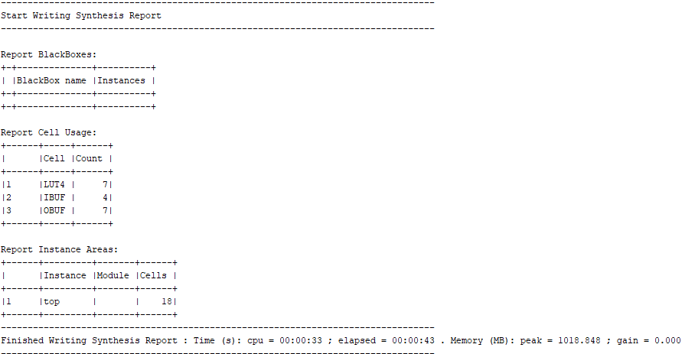

POWER REPORT:-

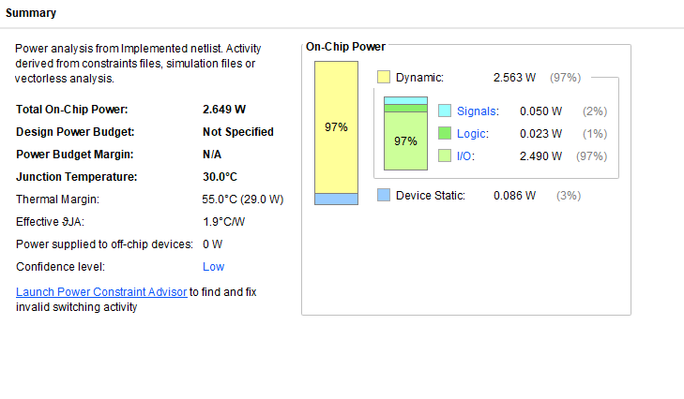

Q22. SERIAL ADDER

VERILOG CODE:-

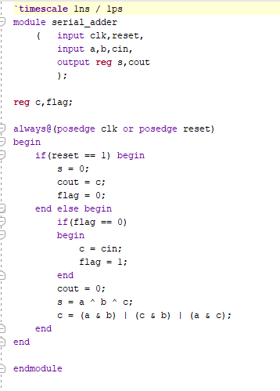

TESTBENCH:-

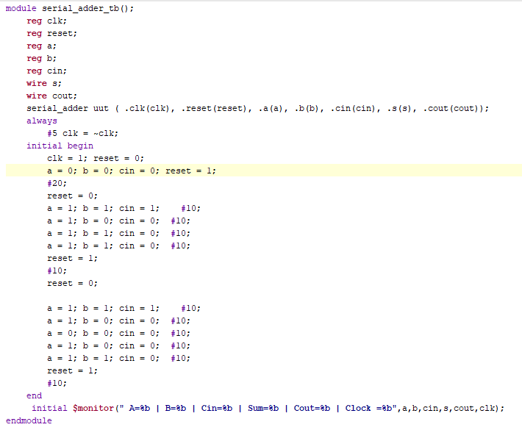

RTL SCHEMATIC:-

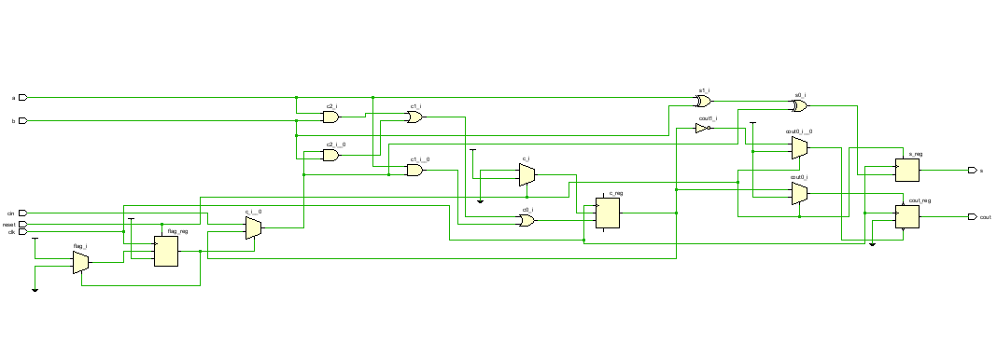

SYNTHESIS REPORT:-

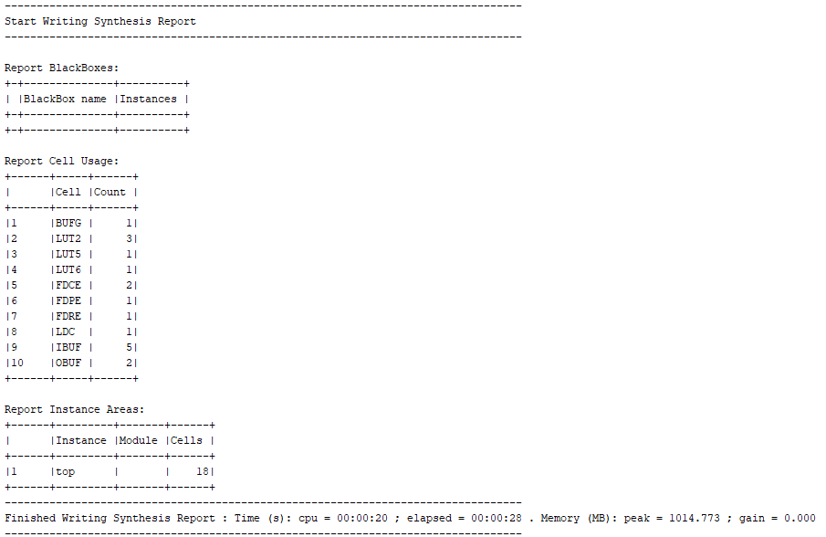

POWER REPORT:-

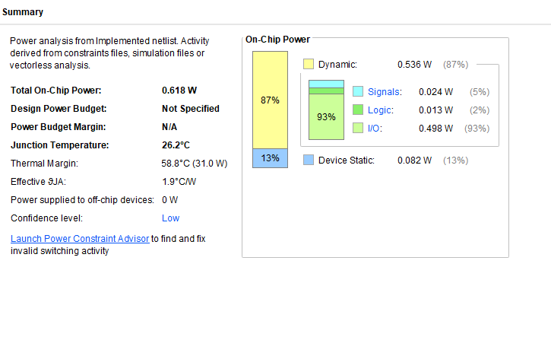

Q23. FIXED PRIORITY ARBITER

VERILOG CODE:-

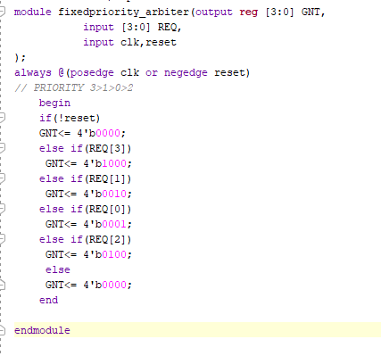

TESTBENCH:-

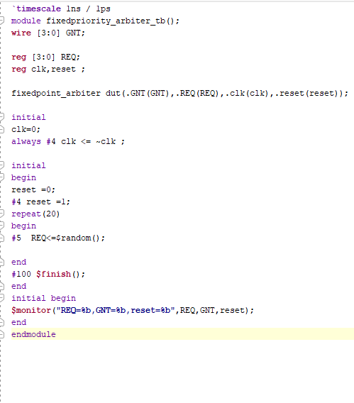

RTL SCHEMATIC:-

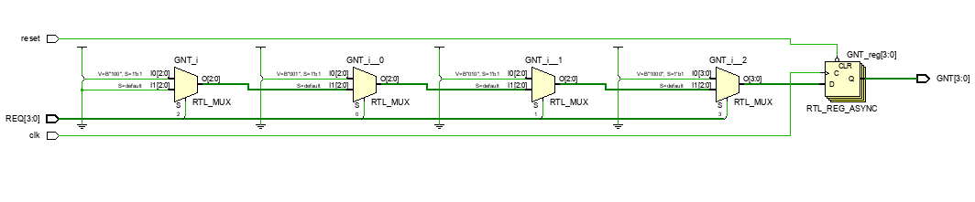

SYNTHESIS REPORT:-

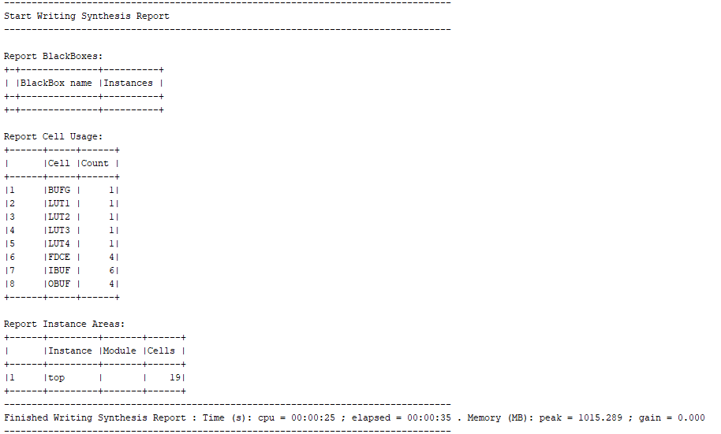

POWER REPORT:-

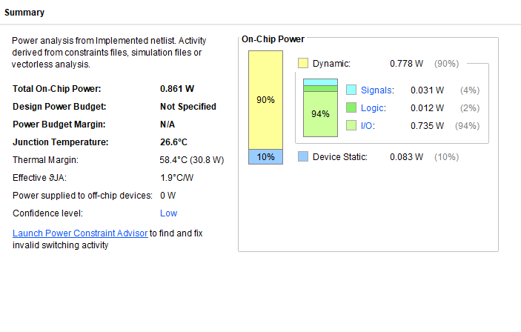

Q24. ROUND ROBIN ARBITER

VERILOG CODE:-

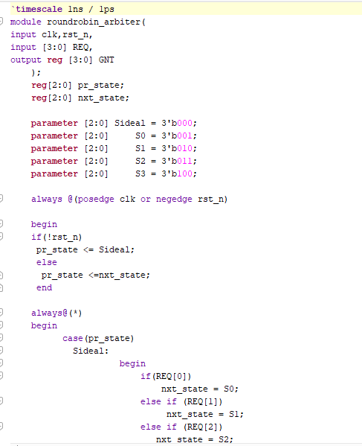

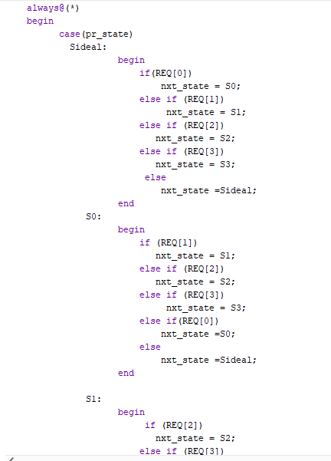

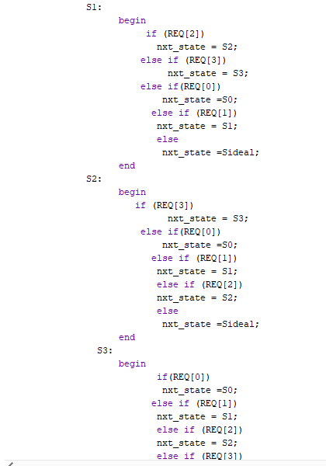

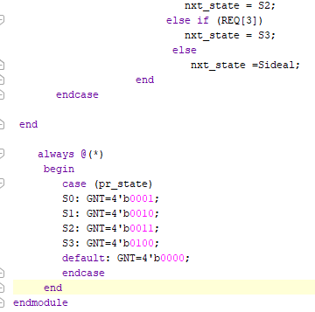

TESTBENCH:-

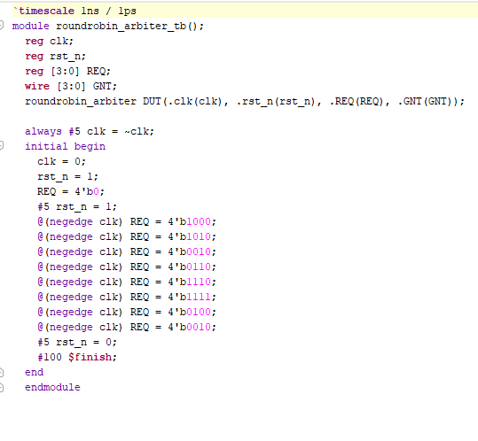

RTL SCHEMATIC:-

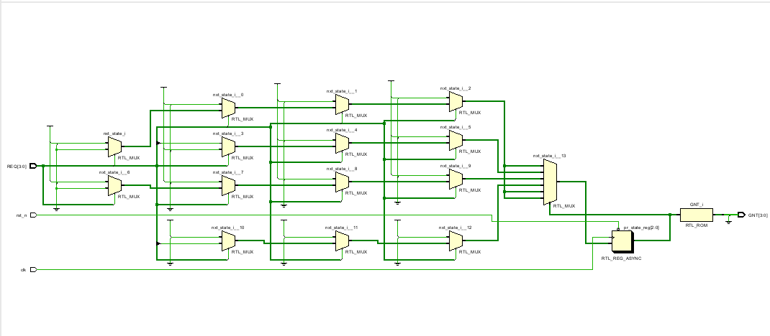

SYNTHESIS REPORT:-

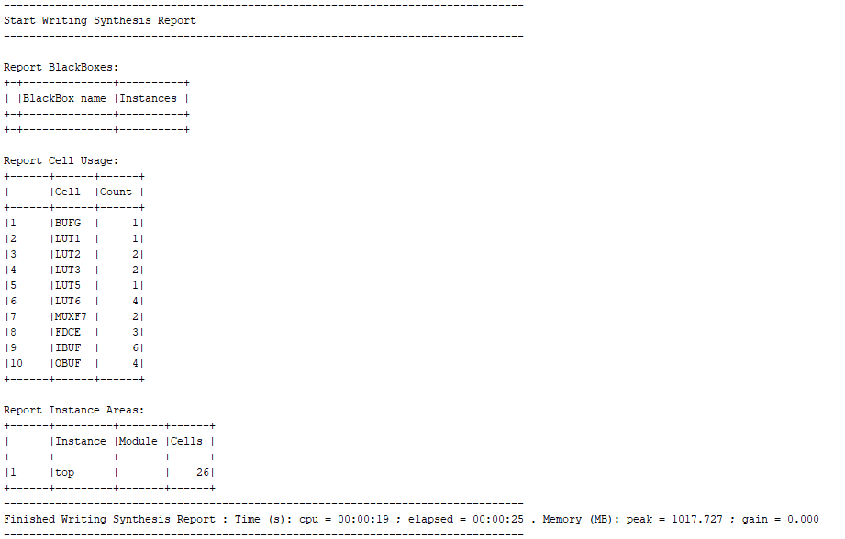

POWER REPORT:-

